CLOUD COMPUTING LAB

Name: Maria Abdul Malik
Reg No: 2023-BSE-076
Submitted to: Sir Muhammad Shoaib
Class: 5B
LAB #03
Task 1 – Handling Local and Remote Commit Conflicts (Pull vs Pull --rebase)
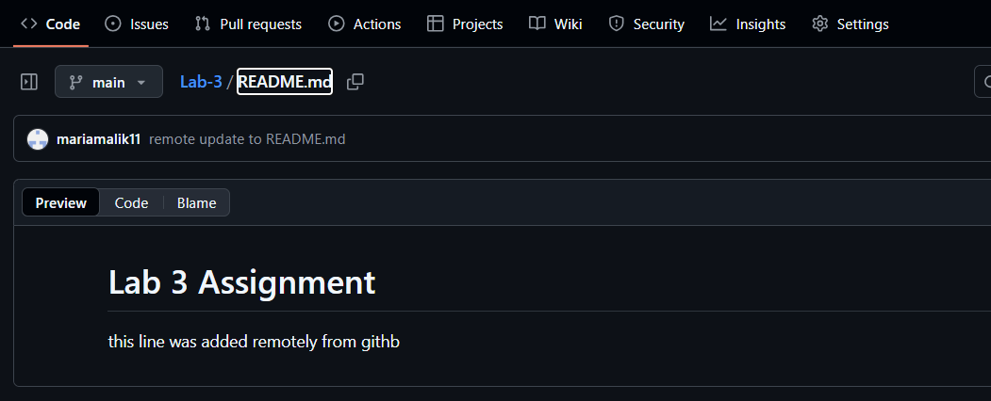
Remote_edited.png
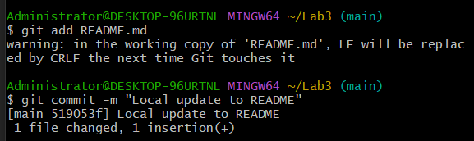
Local_commit.png
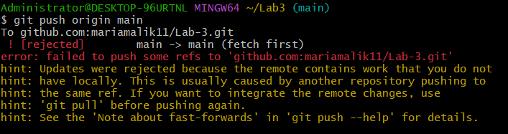
Push_error.png
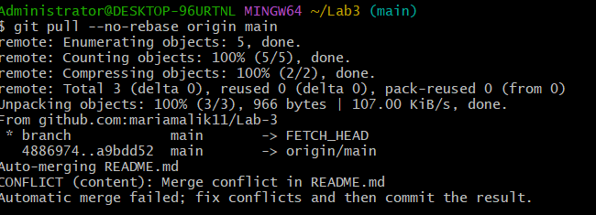
Merge_commit.png
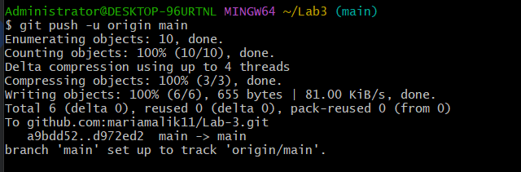
Push_after_merge.png
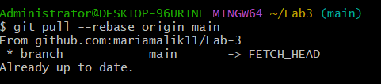
Rebase_pull.png
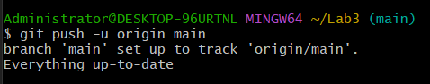
Push_after_rebase.png
Task 2 – Creating and Resolving Merge Conflicts Manually
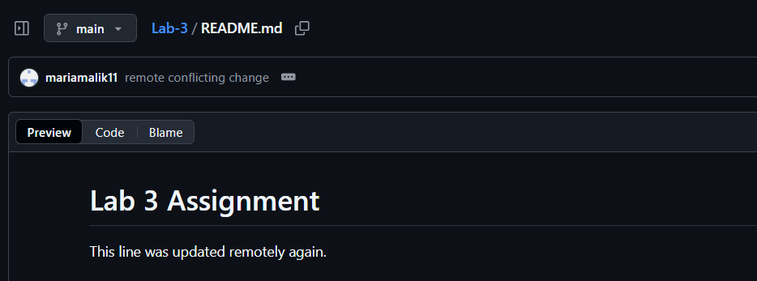
Remote_conflict edit
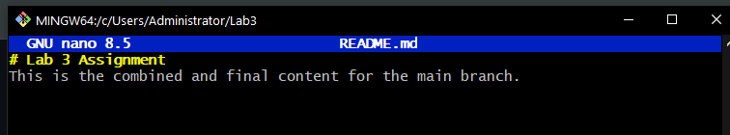
Local_conflict edit.png
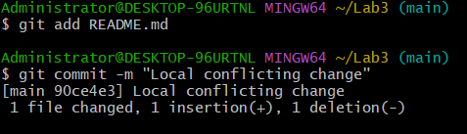
local_conflict_commit.png
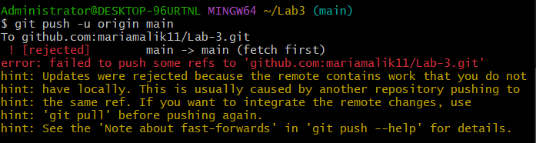
conflict_push_error.png
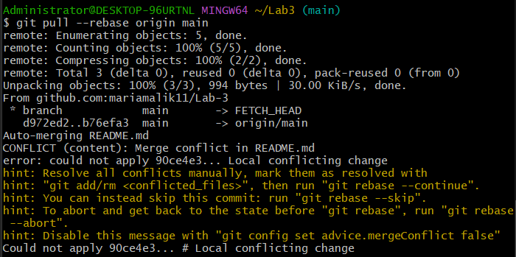
conflict_message.png
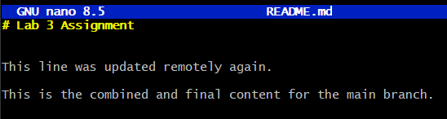
Resolved_README.md
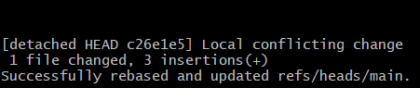
Rebase_countine.png
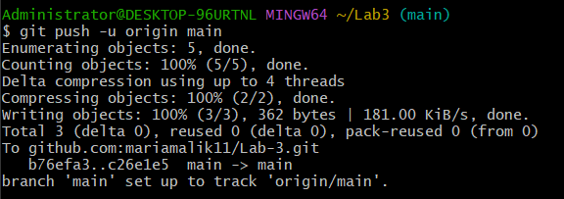
Push_after resolve.png
Task 3 – Managing Ignored Files with .gitignore and Removing Tracked Files
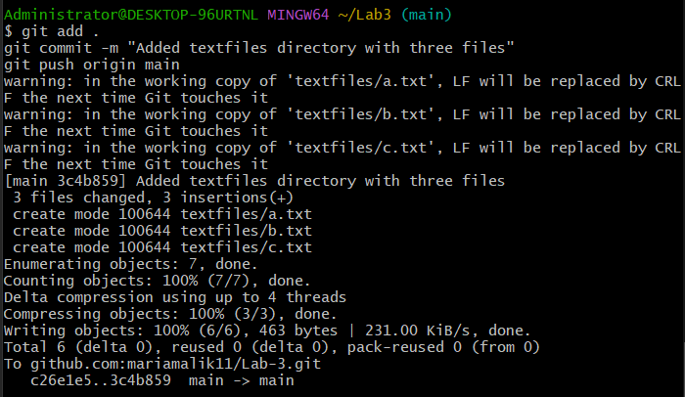
Pushtext_files.png
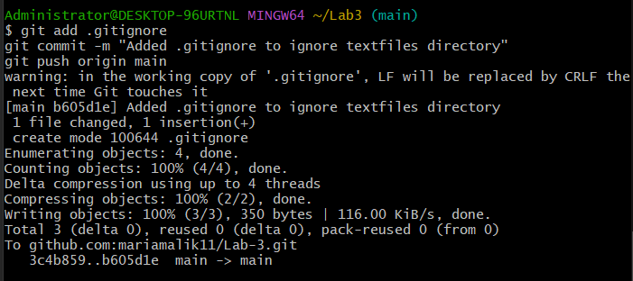
Git_ignore_push.png
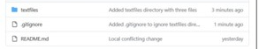
Repo still has text file.png
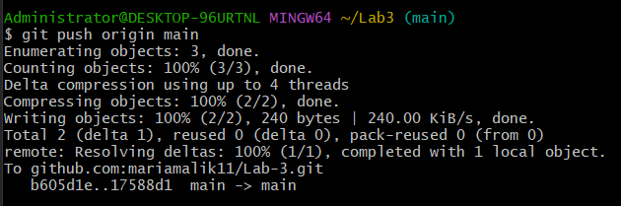
Rm_cached push.png
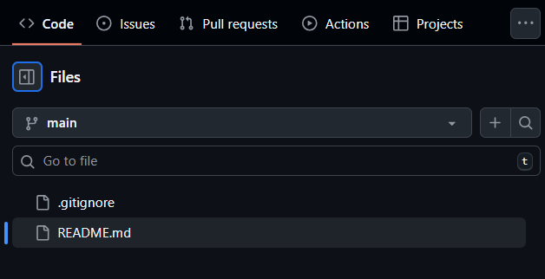
Repo textfiles removed.png
Task 4 – Create Temporary Changes and Use git stash
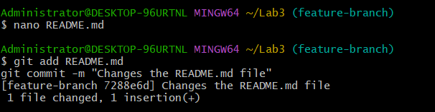
Modified_README.md
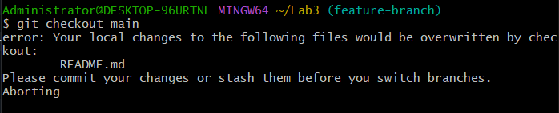
Checkout_error.png
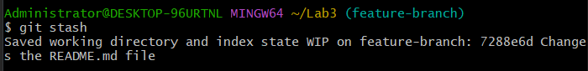
Stash_command.png
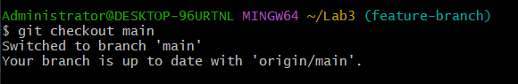
Branch_switches.png
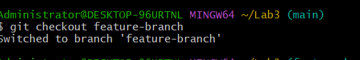
Back_to_feature.png
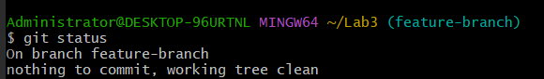
Status_clean.png
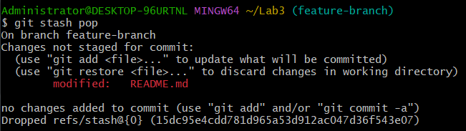
Stash_pop.png
Task 5 – Checkout a Specific Commit Using git log
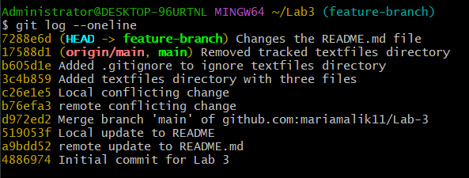
Log_before_checkout.png
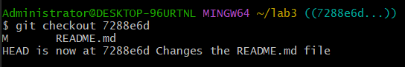
Detached_headed.png
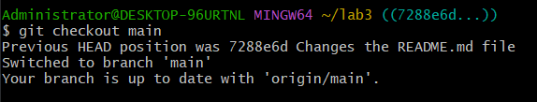
Back_to_main.png

Task 6 – Resetting Commits (Soft vs Hard Reset) (With Verification Steps)
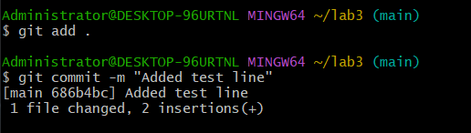
First commit.png
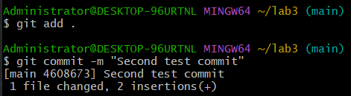
Second_commit.png
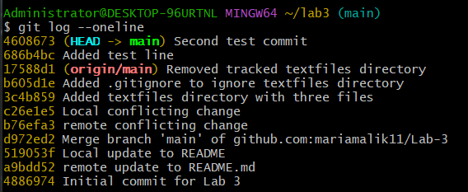
Log_before_reset.png
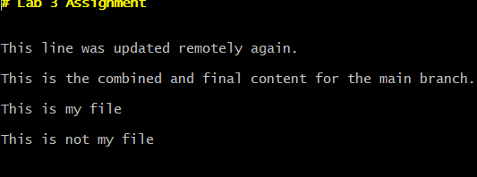
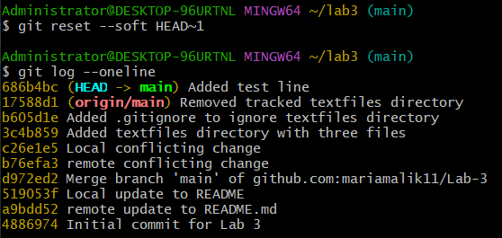
Soft_reset.png
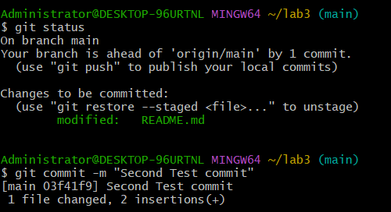
File_after_hard_reset
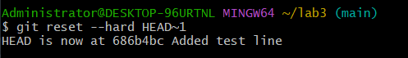
Hard_reset.png
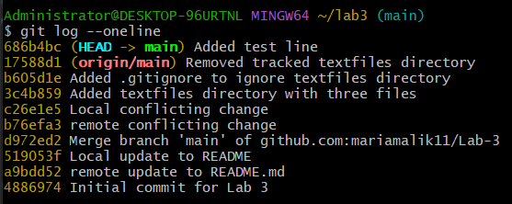
log_after_hard_reset.png
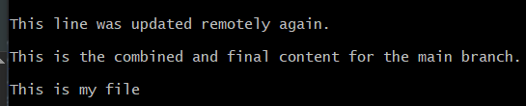
file_after_hard_reset.png
Task 7 – Amending the Last Commit:
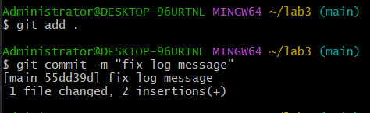
First_amend-commit
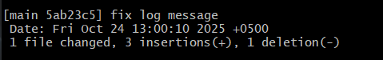
Amend_commit.png
Task 8 – Reverting a Commit (Safe Undo on Remote Branch):
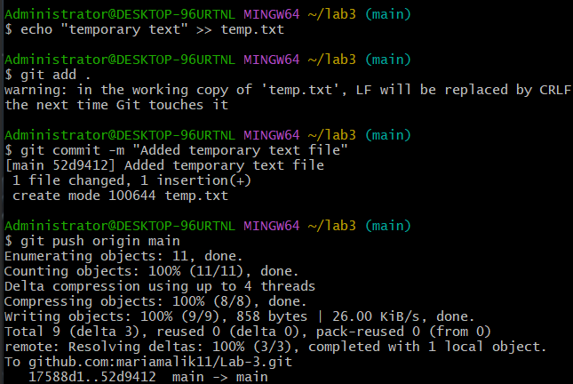
Commit_temp_file.png
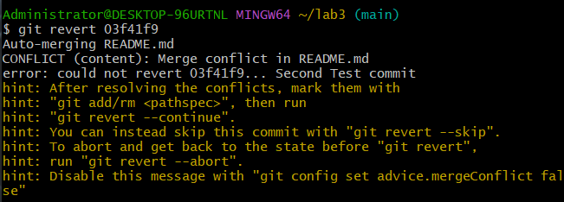
revert_commit.png
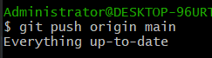
Revert_push.png
Task 9 – Force Push (With Caution):
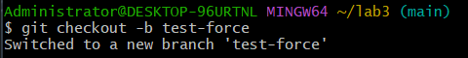
New_branch.png
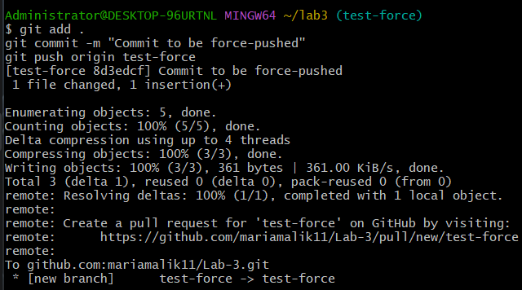
Force_commit.png
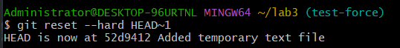
Hard_reset_force.png
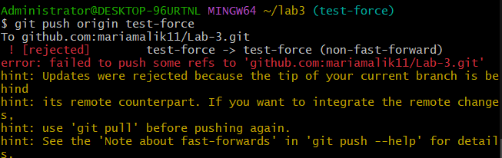
normal_push.png
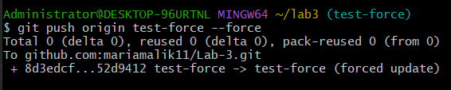
Force_push.png

Task 10 – Running Gitea in GitHub Codespaces via Docker Compose:
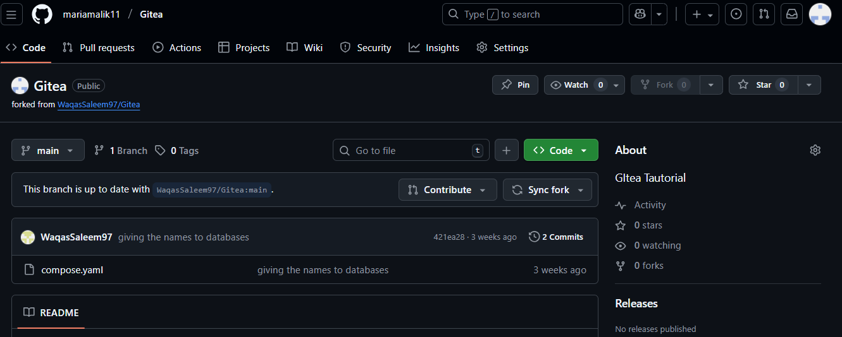
forked_gitea.png
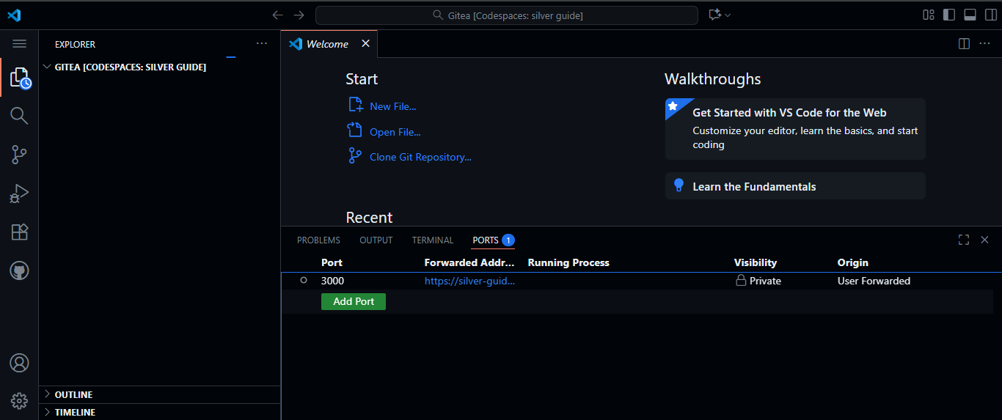
Codespace_login.png
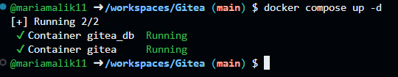
Docker_up.png
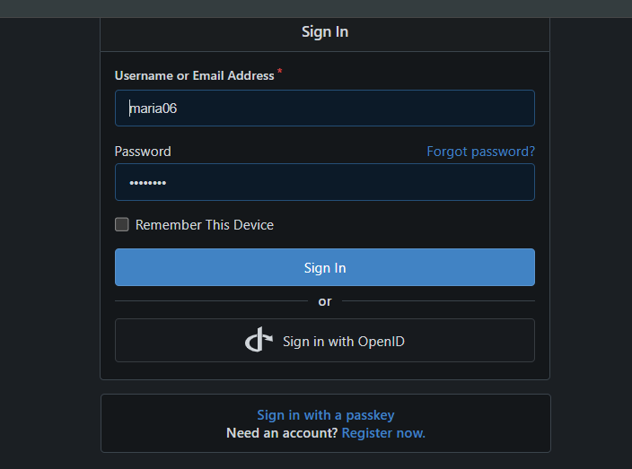
Install_gitea.png
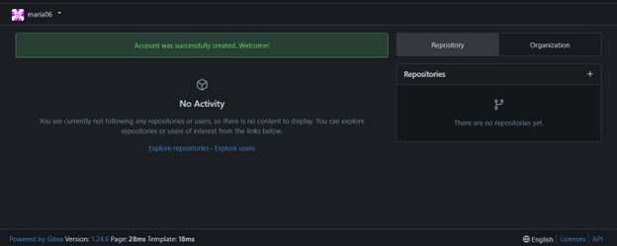
gitea_dashboard.png
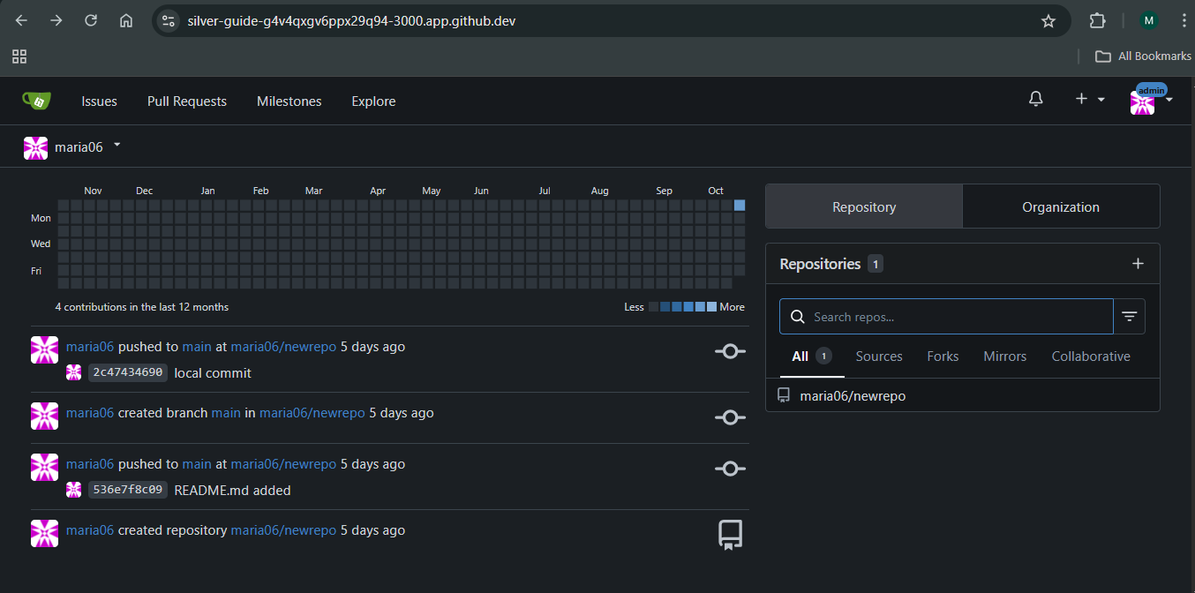
Gitea_repo.png

Task 11 – Creating a GitHub Pages Portfolio Site

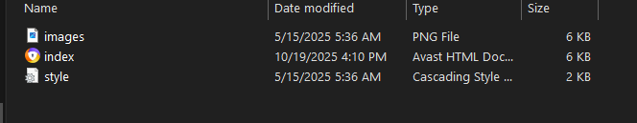
local_static_site.png
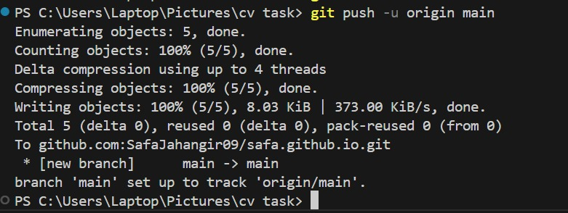
push_static_site.png
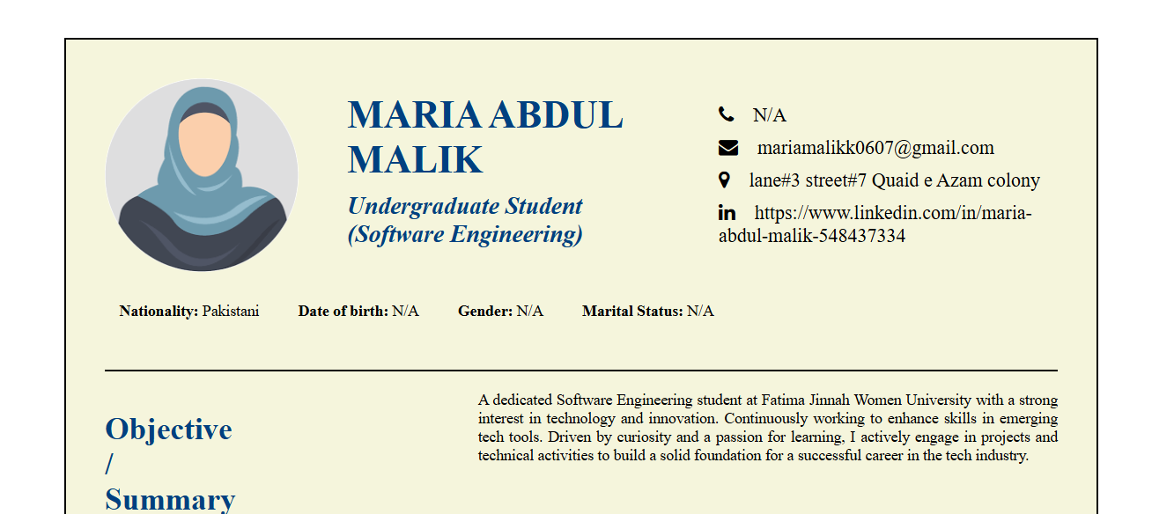
live_site.png

